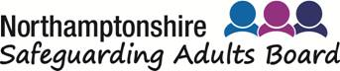

NORTHAMPTONSHIRE SELF-NEGLECT RISK ASSESSMENT TOOL

This form is intended to support multi-agency information sharing and decision making. It has 3 uses to support collaborative working and can be used by any agency to:
1. Gather information
2. Assess risk faced by an adult where there is a significant concern about self-neglect. Not all sections may be completed by the time agencies meet. The content may change as information is shared/updated, and a clearer picture of the person’s circumstances emerges. The final section can be used to record the outcome of any improvements.
3. Multi-agency strategy meeting is held to discuss concerns to plan a way forward and record decisions (Best Interest meeting where the individual has no capacity) or (Adult Risk Management meeting where the individual does have capacity).

Person’s Details
Name
Date of Birth
Address
Contact details
Type and tenure of accommodation
Landlord
Contact details

Question | Please summarise
Summary of concerns raised by other about the adult
Summarise the adult’s strengths and what is going well
Summarise the adult’s view of others’ concerns about their welfare and/or environment

Mental Capacity
What is known about the adult’s mental capacity to understand the consequences of their decisions about the way they manage their environment and welfare?

Other Household Members
Name | Relationship | Date of Birth

Pets
Type and number of | Any concerns?

Agencies Currently Involved
Name | Agency | Role | Contact details

Informal Support
Name | Relationship | Support provided | Contact details | Key holder
 |  |  |  | YES/NO
 |  |  |  | YES/NO
 |  |  |  | YES/NO
 |  |  |  | YES/NO

Care Act Advocate
(Adult with care and support needs, subject of an Adult Safeguarding Enquiry, has substantial difficulty in participating in that enquiry and has no one else to support them)

Name | Contact details

Concerns About Care of Self and Others
Concern | Answer
Is the person getting enough to eat/drink? | YES/NO
Is the person managing personal hygiene? | YES/NO
Is the person managing treatment/medication? | YES/NO
Is anyone preventing the adult engaging with services or support? | YES/NO
Neglect of children (children living in households where self–neglect is suspected must be referred to the MASH immediately. Contact the MASH on 0300 126 7000) | YES/NO
Neglect of other dependent adults (where there are concerns about dependent adults and self-neglect is suspected, a safeguarding referral should be considered. Contact North Northamptonshire - 0300 126 3000 or West Northamptonshire - 0300 126 7000) | YES/NO
Neglect of animals | YES/NO

Vulnerability
Vulnerability Type | Answer
Poor mental health | YES/NO
Poor physical health | YES/NO
Poor mobility | YES/NO
Cognitive difficulties | YES/NO
Target within local community “Hate crime” | YES/NO
Socially isolated | YES/NO
Likely to be vulnerable to 'counterfeit friendships'/ “Mate crime” | YES/NO
Alcohol/Substance misuse | YES/NO

Other (please describe)

Living Environment Assessment
Score 1 – 9 for each room using the Clutter Image Rating Scale as a guide.

Room | Score |  | Room | Score
Bedroom 1 |  |  | Lounge
Bedroom 2 |  |  | Separate toilet
Bedroom 3 |  |  | Bathroom
Hallway |  |  | Dining room
Kitchen |  |  | Other areas

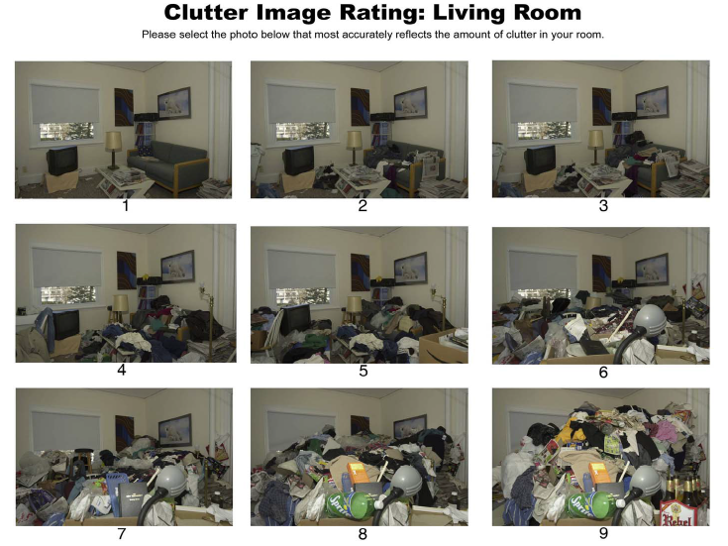
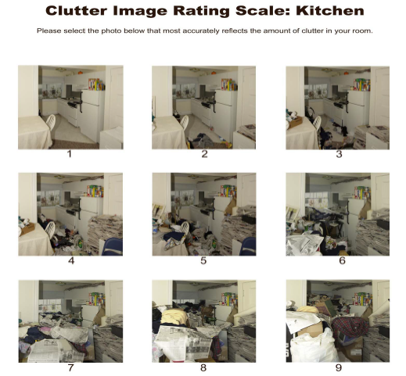
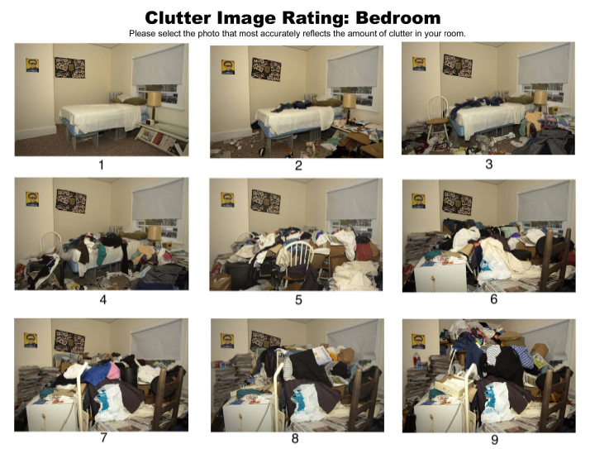

Condition of Garden

Hoarding Details
Food items | Newspapers | Books | Animals
Building materials | CDs/DVDs/Videos/ | Electrical items | Furniture
Clothing | Packaging | Boxes/bags | Correspondence
Bio-hazardous waste¹ | General items | Collectables

Other (Please state)

¹ Bio-hazardous waste could include: Human blood and blood products (includes items that have been contaminated with blood and other body fluids or tissues that contain visible blood); animal waste; human body fluids; sharps waste.

General Living Environment Risks
Question | Answer
Is there an imminent fire risk? (consider flammable materials, working smoke alarms, evidence of previous smoke or fire damage, using gas bottles for cooking etc.) | YES/NO
Is hoarding limiting free movement? (consider entry/exit- is there an escape route should there be a fire?) | YES/NO
Is the kitchen usable? | YES/NO
Is the bathroom/toilet usable? | YES/NO
There is a risk of stacked items collapsing | YES/NO
Are utilities disconnected? | YES/NO
Are urgent repairs required? | YES/NO
Are there concerns over the state of gas fittings?  (i.e. are gas safety checks are overdue) | YES/NO
Concern over state of wiring/electrical fittings (i.e. electrical safety checks are overdue) | YES/NO
Is a fire safety check overdue? | YES/NO
Is there infestation of property? | YES/NO
Is the infestation affecting neighbours? | YES/NO
Is there rubbish outside property affecting neighbours? | YES/NO
Is there structural damage to property? | YES/NO
Is there bio-hazardous waste? (including bodily fluids) | YES/NO
Is there presence of discarded sharp objects? | YES/NO
Is the property a target of vandalism? | YES/NO
Does the condition of the property prevent delivery of care? | YES/NO
Are there other concerns about the living environment? | YES/NO

Any Other Issues About the Living Environment

Person’s View on Property and Self Neglect Concerns

Question | Answer
Are they willing to improve the condition of the property? | YES/NO
Is support needed for them to do this? | YES/NO

Description of Support Needed

Risk Assessment 1 – Risk to the Adult
Summary of Risk to the Adult From Their Self-Neglecting Behaviour

Risk Control Measures
What is already in place to address the risk of harm to the adult.
Consider how it is working and how sustainable it will be in the future.
Existing risk control measures | Who is responsible | How sustainable are these measures? | Impact - How well are the measures working to reduce risk?

Risk Assessment Conclusion – Risk to the Adult
How likely is the risk to the adult?
Rare/unlikely | Possible | Likely | Certain

Give reason for judgement:

How severe would the impact on the adult caused by Self-Neglect be if it continues?
Low | Moderate | High | Extreme
Give reason for judgement:

Overall level of risk/danger to the adult from self-neglect - See risk matrix below

Risk Assessment 2 – Risk to others
Summary of risks to other people caused by the adult’s self-neglect behaviour

Risk Control Measures
What is already in place to address the risk of harm to other people from the adult’s self–neglect behaviour?
Consider how well it is working and how sustainable it will be in the future.
Existing risk control measures | Who is responsible? | How sustainable are these measures? | Impact  How well are the measures  working to reduce the risk?

Risk Assessment Conclusion – Risk to other people
How likely is the adult’s self-neglect behaviour to impact upon others?
Rare/Unlikely | Possible | Likely | Certain
Give reason for judgement:
How severe would the impact of the adult’s self-neglect be upon others if the behaviour continued?
Low | Moderate | High | Extreme
Give reason for judgement:
Overall level of risk/danger to others from the adult’s self-neglect behaviour - See risk matrix below

Outcome of the ARM Meeting (see website for toolkit)

Details | Please complete
Date of meeting
Venue

People contributing to this meeting (please advise who the Chair of the ARM is)
Name | Agency | Contact details

Outstanding
Concern | Potential solutions considered

Agreed Actions
Action | Owner name and agency | By when

Date plan will be reviewed
Lead Person responsible for coordinating review
Organisation

Evaluating Risk
In case of Emergency (Police, Ambulance and Fire), call 999. For Police non-emergency, dial 101.
Risk Scoring and Grading
The risk matrix below shows both numerical scoring and colour banding and may be used in combination with the guidance on types and seriousness of abuse.
Use the table below to calculate the risk score by multiplying the consequence by the likelihood: C (consequence) × L (likelihood) = R (risk score)
Probability/Likelihood |  |  | Consequence/Impact
 | Negligible (1) | Minor (2) | Moderate (3) | Major (4) | Catastrophic (5)
Almost certain (5) | 5 | 10 | 15 | 20 | 25
Likely (4) | 4 | 8 | 12 | 16 | 20
Possible (3) | 3 | 6 | 9 | 12 | 15
Unlikely (2) | 2 | 4 | 6 | 8 | 10
Rare (1) | 1 | 2 | 3 | 4 | 5

For grading risk, the scores obtained from the risk matrix are assigned grades as follows:
1–3 - Low risk 4–6 - Moderate risk 8–12 - High risk 15–25 - Extreme risk
1 - 3 Low risk – Not suitable for ARM
4 - 6 Moderate risk – Not suitable for ARM
8 - 12 High risk – Serious impact on a person’s life leading to possible serious injury or serious impact on the person’s life i.e. loss of life savings etc.
15 - 25 Extreme risk – Serious impact on a person’s life which could lead to serious injury/death

